Design of an IoT System for Monitoring of Elderly People

Adrián González   
Internet of Things  
UABBellaterra, Spain  
adrian.gonzalezo@autonoma.cat

Gabriel Juan  
Internet of Things  
UABBellaterra, Spain  
gabriel.juan@autonoma.cat

Adrián García Tapia  
Internet of Things  
UABBellaterra, Spain  
adrian.garciat@autonoma.catYoussef Cahouach Huella Ikhlaf  
Internet of Things  
UABBellaterra, Spain  
Youssef.CahouachGuella@autonoma.cat

***Abstract*—** **This document presents the design of an IoT-based system aimed at monitoring elderly individuals by detecting unusual movements and sounds in their surroundings. The system integrates multiple sensors for data collection, processes the information locally using edge computing, and triggers alerts when anomalies are detected. The proposed solution addresses the growing need for innovative care systems, particularly in environments where constant human supervision is not feasible. Through an initial market study, we compare existing solutions and highlight the advantages of our approach, including its capabilities and cost-effectiveness.**

***Keywords—*** *I****oT, elderly care, edge computing, anomaly detection, sensors, health monitoring, predictive analysis.***

# Introduction

The increasing global aging population presents significant challenges for caregivers, healthcare providers, and families. In many cases, constant human supervision of elderly individuals is not feasible, especially in situations where they live alone or have limited access to in-person care. To address this issue, IoT-based monitoring systems offer a promising solution, providing continuous surveillance while enabling remote alerts in the event of unusual activity.

This paper proposes an IoT system that integrates multiple sensors to detect movements and sounds in the environment of elderly individuals. The collected data is processed locally using edge computing to reduce latency and ensure real-time responses. The system is designed to monitor daily activity patterns, detect anomalies, and notify caregivers or emergency services when needed. The overarching goal is to enhance the safety and well-being of elderly individuals, providing peace of mind to their caregivers.

In the following sections, we will outline the technical specifications of the system, conduct a preliminary market study on existing solutions, and discuss the differentiating aspects of our proposal, including its capabilities, cost-effectiveness, and scalability. Additionally, we will address the usability of the system from the perspective of its target users and provide a roadmap for future development and deployment.

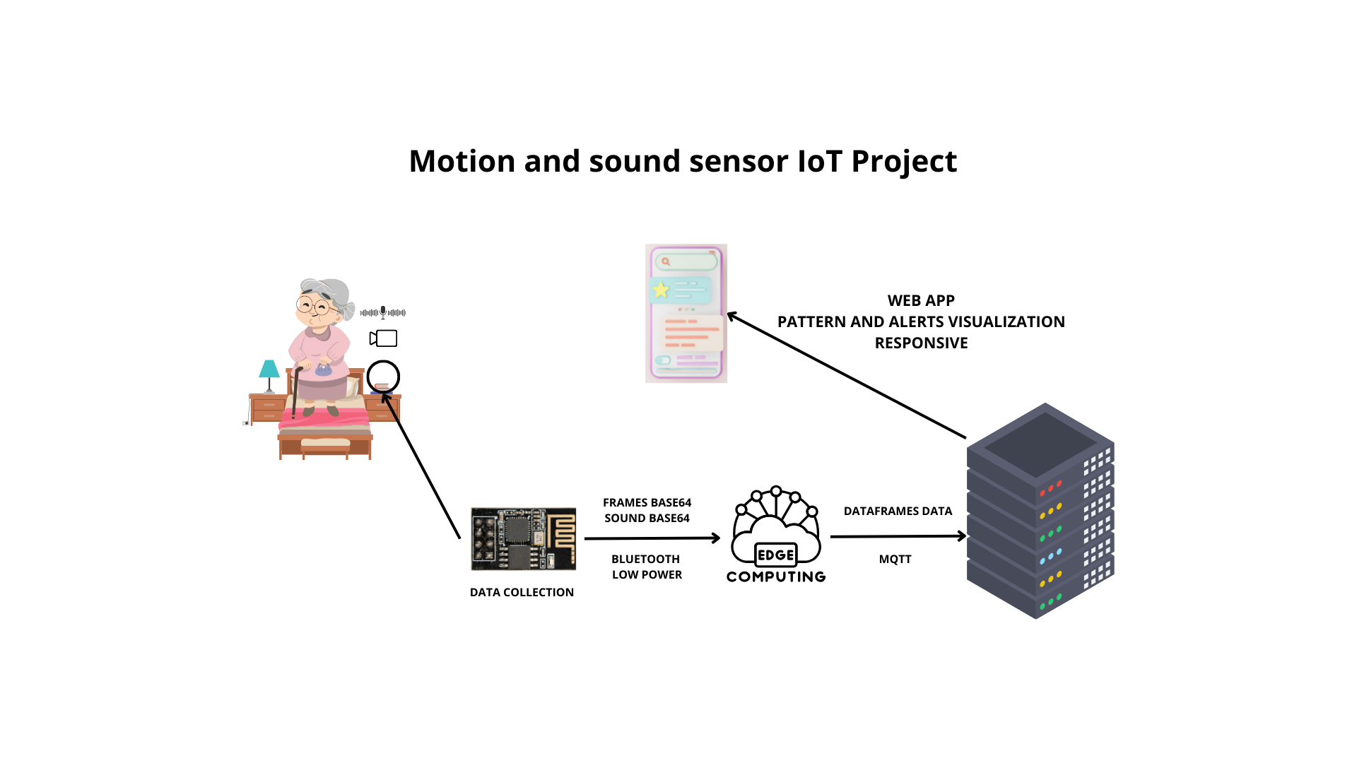

# PRELIMINARY MARKET RESEARCH

To validate the originality of the proposed IoT-based elderly monitoring system, a preliminary market study was conducted to analyze existing solutions. The study focused on cost, functionality, and performance, highlighting potential competitors and gaps that the proposed system aims to address.

## CarePredict [1]

* $449 initial hardware setup, $69/month subscription.
* Uses wearable sensors to monitor daily activities such as walking, eating, and sleeping. Machine learning algorithms detect deviations from normal patterns and send alerts to caregivers.
* CarePredict effectively tracks gradual changes in behavior but relies heavily on wearables, which may result in compliance issues due to user reluctance or forgetfulness.

## Curo [2]

* Starts at $60/month, additional hardware fees apply.
* Utilizes non-invasive sensors placed around the home to monitor activities such as door usage and appliance interaction. Caregivers receive real-time updates through a dedicated app.
* Provides robust data on daily routines but lacks advanced predictive analytics for preemptive emergency detection.

## SafeBeing [3]

* $30-$50/month, variable hardware costs.
* Utilizes wearables to monitor hydration, sleep, and falls. The system uses AI for real-time alerts and provides long-term insights into user behavior trends.
* Offers comprehensive monitoring, but like CarePredict, relies on continuous wearable usage, which can be a limitation for some users.

## Walabot HOME [4]

* $249 hardware, no monthly fees.
* Wall-mounted radar technology detects falls and automatically notifies emergency contacts.
* Excels in fall detection with a non-invasive approach, but its functionality is limited to fall detection only, lacking broader health or activity monitoring capabilities.

## Alexa Together (Discontinued) [5]

* Previously $19.99/month.
* Provided caregivers with remote monitoring, sending notifications if elderly individuals did not perform regular activities, such as interacting with Alexa devices or moving around.
* Although Alexa Together was discontinued, user feedback from Reddit forums indicated that the monitoring feature was the most missed aspect of the service. This insight inspired the development of our system, which focuses on continuous, non-invasive monitoring, addressing the void left by Alexa Together’s discontinuation.

The main competitors for our proposed IoT-based monitoring system are CarePredict, Curo, and SafeBeing, due to their emphasis on multi-sensor or wearable-based solutions. However, the discontinuation of Alexa Together revealed a clear market gap for a reliable, non-intrusive monitoring system that does not depend on wearables—an aspect that many users emphasized as lacking after the service ended.

The proposed IoT system distinguishes itself from competitors in several key areas:

1. **Non-intrusive multisensor monitoring**: Unlike most competitors, our system does not require wearables, offering a more user-friendly experience for elderly individuals who may resist or forget to use such devices.
2. **Real-time edge computing**: This feature ensures immediate anomaly detection and minimizes latency, significantly reducing the likelihood of false alarms.
3. **Inspiration from Alexa Together**: Based on user feedback from the discontinuation of Alexa Together, we aim to fill the gap left by its monitoring capabilities, offering continuous passive monitoring—a feature highly missed by caregivers.
4. **Cost-effectiveness**: Our system provides similar or superior functionality at a lower cost compared to subscription-based services like CarePredict and SafeBeing, making it an accessible option for a wider range of users.

# System Architecture

Each device will consist of a battery-powered camera and microphone, along with a data collector and an edge processing unit. The data collector will send information to the edge, which will then transmit it to a cloud server for further processing. Additionally, there will be a mobile app for caregivers and family members to monitor the status of the elderly.

# Exploitation of cloud computing

The edge will perform only the necessary computing to instantly identify emergencies. However a more in-depth analysis of the gathered data will be done in the cloud which will be reflected on the app. This includes registering the user’s patterns to detect any anomalies to help prevent any future problem like a possible fall. The data and its insights will also be available to any health center as part of the medical records of the patients.

# System Usability: User Storyboard

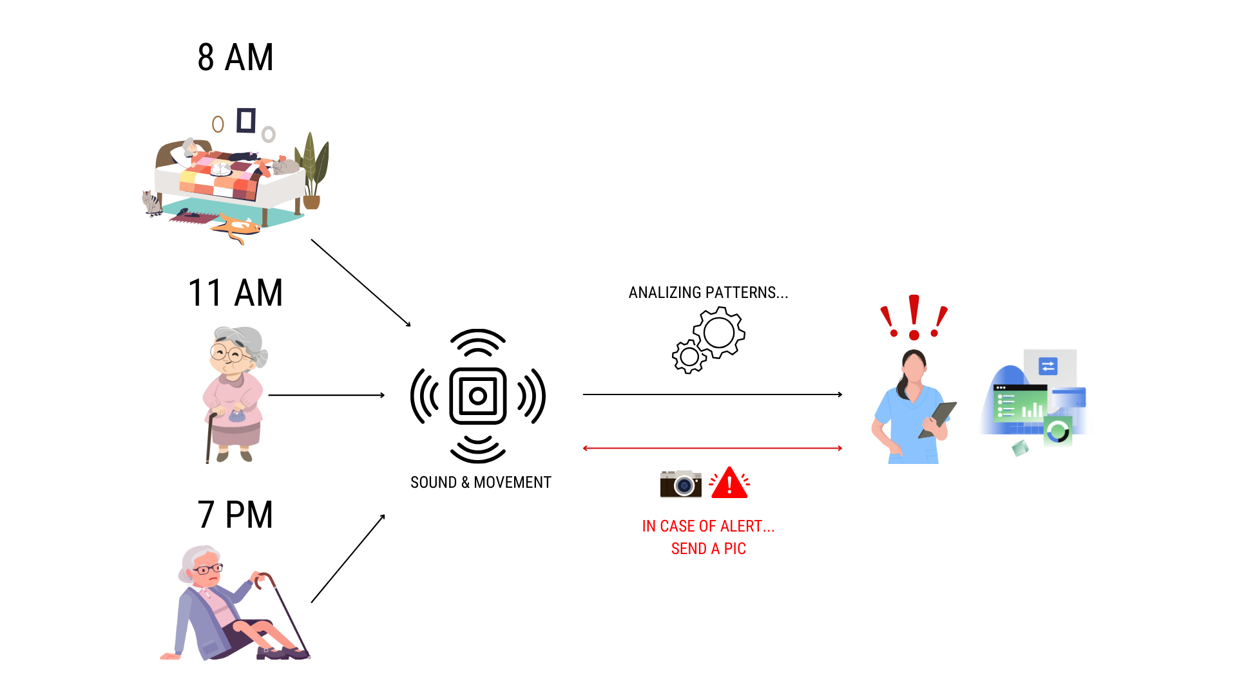

Our system is designed to monitor elderly individuals using motion and sound sensors, providing continuous and non-intrusive supervision to ensure their safety. Throughout the day, the system detects and analyzes daily activities, creating a baseline of normal patterns. For instance, it recognizes regular movements, like getting out of bed in the morning or walking around during the day. If an anomaly occurs, such as a fall or unusual inactivity, the system triggers an alert, notifying caregivers in real-time. Additionally, it captures a photo of the event scene to offer more context and help caregivers respond promptly and effectively. This allows caregivers to monitor loved ones remotely, offering peace of mind and ensuring timely interventions in case of emergencies.

##### References

1. CarePredict, “Wearable sensors for monitoring daily activities,” CarePredict, 2024. [Online]. Available: https://www.carepredict.com/. [Accessed: 14-Oct-2024].
2. Curo, “Non-invasive home monitoring sensors,” Curo, 2024. [Online]. Available: https://www.curo.com/. [Accessed: 14-Oct-2024].
3. Somatix, “SafeBeing: Wearable monitoring for hydration, sleep, and falls,” Somatix, 2024. [Online]. Available: https://www.somatix.com/. [Accessed: 14-Oct-2024].
4. Walabot, “Wall-mounted radar technology for fall detection,” Walabot, 2024. [Online]. Available: https://walabot.com/. [Accessed: 14-Oct-2024].
5. PCMag, “Alexa Together: Remote caregiving with Echo devices,” PCMag, 2024. [Online]. Available: https://www.pcmag.com/how-to/alexa-together-remote-caregiving-echo-device. [Accessed: 14-Oct-2024].